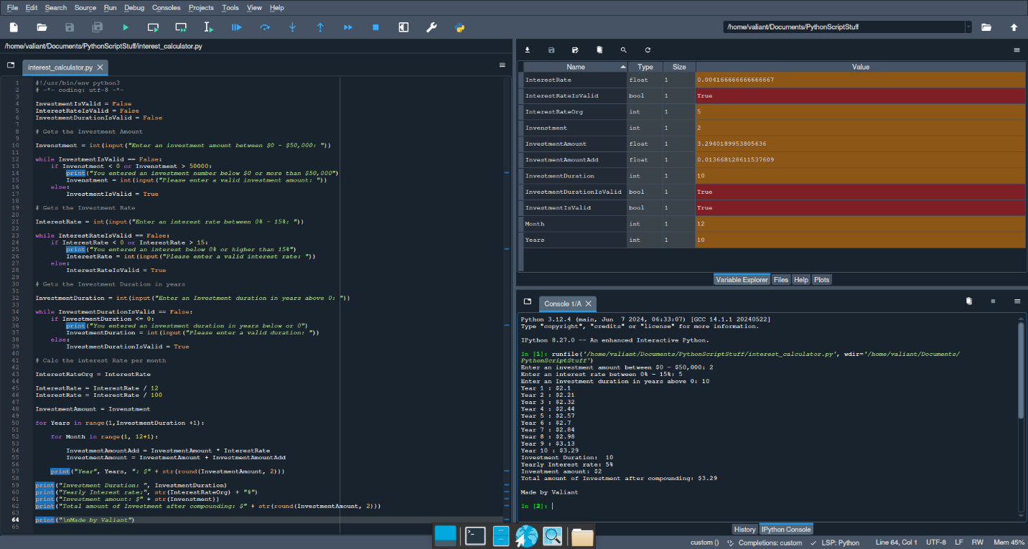

InvestmentIsValid = False

InterestRateIsValid = False

InvestmentDurationIsValid = False

# Gets the Investment Amount

Invenstment = int(input("Enter an investment amount between $0 - $50,000: "))

while InvestmentIsValid == False:

if Invenstment < 0 or Invenstment > 50000:

print("You entered an investment number below $0 or more than $50,000")

Invenstment = int(input("Please enter a valid investment amount: "))

else:

InvestmentIsValid = True

# Gets the Investment Rate

InterestRate = int(input("Enter an interest rate between 0% - 15%: "))

while InterestRateIsValid == False:

if InterestRate < 0 or InterestRate > 15:

print("You entered an interest below 0% or higher than 15%")

InterestRate = int(input("Please enter a valid interest rate: "))

else:

InterestRateIsValid = True

# Gets the Investment Duration in years

InvestmentDuration = int(input("Enter an Investment duration in years above 0: "))

while InvestmentDurationIsValid == False:

if InvestmentDuration <= 0:

print("You entered an investment duration in years below or 0")

InvestmentDuration = int(input("Please enter a valid duration: "))

else:

InvestmentDurationIsValid = True

# Calc the interest Rate per month

InterestRateOrg = InterestRate

InterestRate = InterestRate / 12

InterestRate = InterestRate / 100

InvestmentAmount = Invenstment

for Years in range(1,InvestmentDuration +1):

for Month in range(1, 12+1):

InvestmentAmountAdd = InvestmentAmount * InterestRate

InvestmentAmount = InvestmentAmount + InvestmentAmountAdd

print("Year", Years, ": $" + str(round(InvestmentAmount, 2)))

print("Investment Duration: ", InvestmentDuration)

print("Yearly Interest rate:", str(InterestRateOrg) + "%")

print("Investment amount: $" + str(Invenstment))

print("Total amount of Investment after compounding: $" + str(round(InvestmentAmount, 2)))

print("\nMade by Valiant")